SPORTS IN ANTIQUITY

The most dangerous job of the sport in antiquity

In-Depth Analysis of the Job Duties of Sparsores

By Pasko Varnica

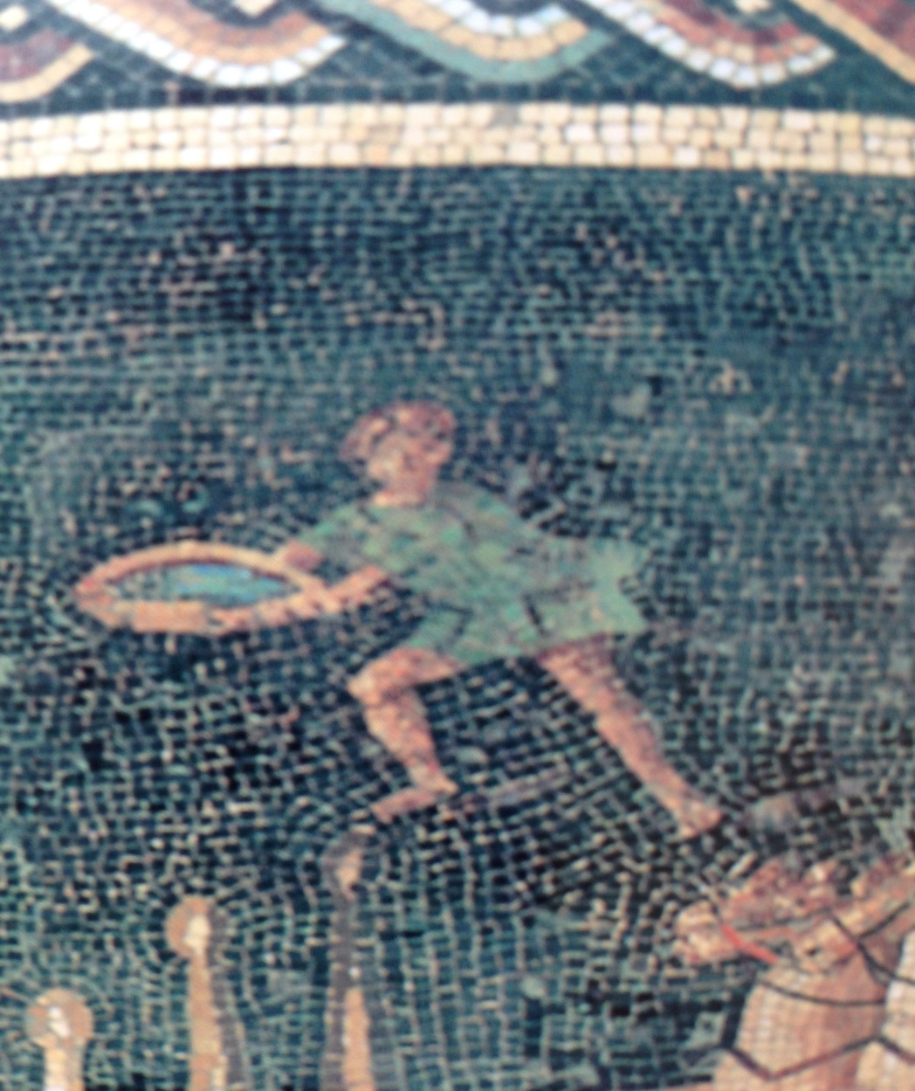

The tunnel under the stands was crowded with stable hands. Felix stood next to his faction’s table, one arm resting on a shallow terracotta basin. Earlier he had filled the basin with fresh water. Now he waited for his dominus to give him the signal to run out to the track.
The race was on the third lap. Two more laps, Felix thought.
Felix could not believe his luck when he learned that the person who bought him at the slave market in Rome six month earlier was a master of the stable of the Greens chariot racing faction. There was no better place to be for a 17 year old in the entire Empire. He was part of the amazing spectacle of chariot racing. He mingled with famous charioteers adored by everyone and worked in the stable with well-known racehorses.
Upon the signal from the dominus, Felix exited to the arena and tip-toed along the wall under the stands, waiting for the right moment to bolt to the middle of the track and fling the water at the approaching chariot of the his Green faction.
Felix died during the sixth lap of the race. The chariot of the Blue faction suddenly veered and hit Felix with its left wheel. The fans of the Blue faction shouted obscenities, upset that their favorite chariot might have been slowed down by the impact. Felix’s dominus was displeased. Now he had to buy and train another sparsor.
Was Felix a sparsor? Most mosaics and other extant material about chariot racing in the Roman antiquity show at least one person standing on the arena’s floor and holding a container filled with either water or another liquid. This person is typically a young man. His job duty has been identified as that of a sparsor. What was his job and what function in the context of a chariot race did he perform? Historians have grappled with the mystery. Has the title of sparsor been properly assigned to this individual?
Let’s examine that last question by first exploring the etymology of the Latin term sparsor. Its English translation offered by contemporary word reference resources like, for example, Oxford Latin Dictionary, is “sprinkler”, that is, a person sprinkling a liquid. This translation probably derives from Studies in the Word Formation of the Latin Inscriptions by George N. Olcott, published in 1898. In it, sparsor or spartor is defined as an attendant who sprinkled the horses. Let’s cut down to the chase. Do you think that an attendant standing on the tracks in a position to fling the content of a basin is really going to “sprinkle” the horses instead of dousing them? The verb to sprinkle was likely associated with an activity not related to the sport of chariot racing and then it stuck with time. An earlier dictionary, the Entick’s English-Latin Dictionary compiled by William Crackelt in 1825 translates sparsor as a person who spreads. That’s more likely.
In modern Italian, which has roots in the old Latin, verb “spruzzare” means to sprinkle. The sound of spruzzare is far removed from Latin sparsor. On the other hand, English translation of the Italian verb “spargere” is to spill, to pour out. The past participle of spargere is “sparso”.
It is now possible to see that sparsor should be translated as “a person who spills, spreads or, rather, pours out” and not as “a person who sprinkles” a liquid. This is an important distinction because the three figures identified as sparsores on chariot race mosaics have each a different shape container.
One figure has a wide and shallow basin in his arms, like our Felix. Another figure holds a wide-mouth terracotta vase or flask. A tile of the beautiful Mosaic Floor at Carthage, Tunisia also known as Horses’ mosaic of Carthage has a panel with a person with such a vase. The title given to this panel is sparsor. The vase has a pointed end, which means that its purpose is to hold a liquid. Romans built vases and other type of containers with a pointed end instead of a flat bottom because it was easier to place them in-ground to keep their content cool. A similar terracotta vase is in the hands of the attendant in the Madrid chariot racing mosaic. Here the race is clearly over. The winning charioteer holds a palm frond. With one hand the attendant is making horses drink water while with the other hand he is holding a vase. The attendant is wearing a tunic the same blue color as the charioteer, meaning that he belongs to the same faction. Each faction had at the least 250 people working for it. It is beyond question that the duty of the person with a wide-mouth vase was not to douse horses during races but rather to carry what’s likely tepid water for the thirsty horses after a race.
The third figure on chariot racing mosaics identified as a sparsor holds an amphora. The amphora is a typical narrow-neck, double-handed kind. Due to the amphora’s neck, the liquid cannot be poured out in large amounts at once. That is, a person having an amphora could only sprinkle. In my opinion, this lead to the current translation of sparsor as a sprinkler.
It is reasonable to assume that the three attendants, one holding the round basin, one with an amphora and the third with a vase performed different functions and should not be grouped under the same label or job title of sparsor.
I assert that only the person holding the shallow basin was a real sparsor, that is, a person pouring out and not sprinkling, a liquid. That liquid in question was obviously water.
There are three hypotheses about the water’s potential target. The targets are the head of the horses, their bodies and the axles of the chariots. Each hypothesis is plausible. Water to the horses’ heads would clean their nostrils of the dust swirling up from the arena floor. Cold water to the horse’s bodies would cool them down. Since Romans were unfamiliar with lubricants, chariots’ axles may get hot during a race and could benefit from a coolant. Alternatively but quite unlikely, the water was intended to remove the dust from the axles.
Water for the nostrils is the least credible possible choice for the simple reason that the probability of hitting the target, that is, the heads of on-rushing galloping horses, was practically zero. I personally lean towards the hypothesis that the sparsor threw the water in the direction of the body of the horses. Romans were familiar with horseracing husbandry as much as we are today, maybe even more. They knew that racehorses have a physical limit in terms of the length of the racetrack. Allowed to continue beyond the stated limit, horses would slow down or collapse, negating the enjoyment of the competition. The actual distance of chariot racing depended by the radius taken at each of the six turns around the barrier. Approximating the turns, chariot races at the bigger arenas were about 2.3km long, a length close to that of today’s Belmont Stakes (Elmont, NY), which is 2.4km long. The total length of a race run in smaller circus arenas was a tad below 2km. Not coincidentally, the length of the Kentucky Derby is 2km. Races at the Santa Anita racetrack are also around 2km.
Unlike the modern races, horses were rider-less and typically, either two or four horses drew a chariot in Roman times. Although other configurations existed, a 4-horse chariot was the most common arrangement. Body heat emanating from four horses yoked together, close proximity of the adjacent horses and the friction of their bodies likely caused overheating. A shower of nice cold water must have been welcome.
Has a sparsor ever missed the horses and splashed the charioteer?
If the duty of sparsores were to refresh horses, should mosaics found in the warmer climates depict them? Neither the great mosaic of Barcelona nor the one found in the nearby Girona have one. Catalonia in the south of Spain qualifies as a warm climate region. What should one conclude from the absence of a sparsor on these mosaics? My guess is that artists copied from existing works available to them instead of composing mosaics by finding their inspiration in real events. Any explanation is of course speculative.
The picture on this web page was taken from the Lyon mosaic. The person holding the basin is standing near the end of the return lap, facing the oncoming chariots, his body in a ready position to fling the water. The mosaic does not have any other sparsores.
Lyon mosaic is not the only original record of sparsores. The little that is left of the mosaic of Gafsa (from southern Tunisia) has a person with a round basin.
While the Barcelona mosaic does not have a person with a basin, it contains a person holding an amphora. The amphora appears raised over the head as in celebration. Mosaics from Carthage and Piazza Armerina also have figures with amphorae held high. Some historians have speculated that the amphora may contain perfume. Was the amphora used to douse in perfume the winner at the end of a race? Yeah, right, like we guys are into that. Nevertheless, a shower of some kind of flower extract could have had some magical or religious significance. In this case, the amphora holder is the real sprinkler. Having said that, his title in Latin should derive from the verb pluo. English translation of pluo is to shower, to sprinkle or to drip. This person should be known as a pluor.
The mosaic from Carthage, which appears to be without a sparsor, has a damaged section located at the end of the barrier. Only the legs are visible today. It is conceivable that the legs belong to a sparsor holding a shallow basin.
The Silin mosaic has a person with a round basin. J.H. Humphrey sees three sparsores in it because, as we have seen earlier, any attendant who had anything to do with water is classified as such. Sparsor, the real one, has his left leg bent and his body slightly twisted in a clear ready position to fling the water. A second figure holds a vase. The vase is similar in size to the one we have seen earlier, but this time it has a cover and a flat bottom. Its holder has his legs straight and well planted on the ground. The vase is at the level of the holder’s torso, not high above the head as the amphora in the other mosaics. Nevertheless, the holder is prominently displaying the vase, as if his intention were to bring someone’s attention to it. That someone cannot be anyone other than a charioteer. Is the vase holder’s job duty to entice the charioteer to win by reminding him of his possible prize? Is the vase on the Silin mosaic full of coins, since money spoke then as much as today?
We can assert with confidence that the covered flat-bottom vase was part of the post-race ceremony. Mosaics were not a snapshot in time. They represented the entire event, from the pre-race parade, to the races, the in-between entertainment and the final award ceremony. Most key actors are present in each major mosaic, including, for example, the holder of the palm’s frond that was customarily given to the winner at the end of a race.
That a sparsor is one of the key actors is telling about his overall value. Even an early relief from Ostia shows a person clearly holding a basin with both hands although the lower right arm is missing. The basin is facing the horses. On the left of the relief there is a person holding a vase-like container. The vase is similar to the one in the Silin mosaic and is tightly held in both hands. Undoubtedly, the winner’s prize money.
We have seen that the round basin and the uncovered vase contain water and that the covered vase may be full of coins, but what is in the amphora? In ancient times, amphorae typically held oil or wine. Was the winner sprinkled with oil or wine for magical or religious reasons? Perhaps, but I doubt it. I am not aware of any original materials using pluor. When the mystery from the past is baffling, it is sensible to begin from where we are today. Modern racecar drivers, due to the extreme physical exertion, have an insatiable thirst after racing. When I raced cars, quenching my thirst was on the top of my mind, right after getting my knees to stop shaking. Charioteers and racecar drivers’ efforts are comparable. In addition to the tension, the dust from the arena floor must have ended in the throats of charioteers. Is it unreasonable to assume the amphora contained wine mixed with water intended to quench charioteers’ thirst? If that’s the case, then the amphora held triumphantly high was a welcome sight for the parched charioteers.
Interestingly, the person holding the amphora in the mosaic from Carthage has a whip in his left hand. This mosaic is the only record of a person with an amphora in one hand and a whip in another. A reward to look forward at the end of the race or a whip? Either you get what I have in my right hand or, if you lose, what I have in my left hand? Not really. The attendant with the amphora is probably one of the first people to reach the chariot. He needed a whip to control the horses.
Not all Roman mosaics about chariot racing have faction attendants and stable hands as is the case, for example, of the floor mosaic found in the Roman Villa in Horkstow, UK.
On the topic of UK, the only Roman circus arena in England was discovered recently in Colchester, east of London. The Colchester Archeological Trust commissioned the reproduction of a chariot racing mosaic look-alike. The reproduction is quite large and well done. I commend the author for placing a sparsor and an amphora holder in the picture. A quibble: the amphora holder has a head laurel in his other hand, a detail not found in any of the original materials.
In conclusion, we have seen that the title of sparsor means to spread, to pour out and not to sprinkle. It should be assigned only to race attendants with a shallow wide basin. Their duty was likely to cool the horses down. Individuals with an amphora and those with an open vase are handling water or another liquid but should not be confused with sparsores. The purpose of open vases was likely to bring water for the horses. The amphora may have contained wine for those thirsty charioteers.
According to J.H. Humphrey, - see footnote 7 - sarcophagi are the largest number of sculptures recording races. Although sarcophagi have in general human forms in the bottom row, there is a particular one, in the Vatican Museum and a fragment (from the same sarcophagus?) in the Berlin Museum having two people on the ground, under the horses’ hooves, with heads on the pavement. While charioteers have helmets, these two individuals have their heads bare. Hence, they appear to be race attendants, possibly sparsores, in process of being trampled by the horses. It is conceivable then to assume that accidents of this nature were common. This particular sarcophagus inspired the title of this essay “The most dangerous job of the sport in antiquity”.

Studies in the Word Formation of the Latin Inscriptions by George N. Olcott is freely available on Google eBooks
Entick’s English-Latin Dictionary is freely available on Google eBooks.
For the picture of the pavement and proper source and attribution, see https://www.flickr.com/photos/34561917@N04/5691247850
National Archaeological Museum of Spain, Madrid
Refer to the article Museu d’Arqueologia de Catalunya posted on this web site on 10/20/2014, see Home page
Musee de la Civilisation Gallo-Romain, Lyon, France
Today at the Bardo National Museum, Tunis, Tunisia
The Circus Maximum at Carthage, today the mosaic is in Bardo National Museum, Tunis
Villa Imperiale del Casale, Sicily
Roman Villa in Silin (or Sileen or even spelled Selene), 15km west of Leptis Magna, Tunis
See Suggested Reading on Home page, John H. Humphrey, Roman Circuses, Arenas For Chariot Racing
Vatican Museum, the relief is known as ex-Lateran because originally housed in the Lateran Museum, which ceased to operate in 1970.
Now in the Hull Museum, Hull, UK
You can see the uncovering ceremony by searching on YouTube for “The Colchester Roman Circus Mosaic”.
Vatican Museum, Sala Rotonda, child sarcophagus of Circus Maximum
Pergamon Museum, Berlin

